The Centre for Applied Genomics (TCAG)
Biobanking Facility
New Study

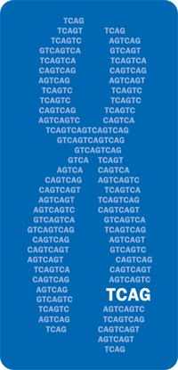 | THE HOSPITAL FOR SICK CHILDREN  Molecular Genetics Laboratory  555 University Ave. Roy C. Hill Rm 3-421  Toronto, Ontario  Canada, M5G1X8  CLIA ID No.: 99D1014032 |  |  |  |  |  |  |  |  |  | Lab contact: Carol Ann Ryan  Tel: (416) 813-6364  Fax: (416) 813-7732  E-mail: carolann.ryan@sickkids.ca  www. tcag.ca/biobanking
Study / Project Name:
Referring Scientist:
Cost centre:
Contact name: |  |  |  |  |  |  |  |  |  |  |  | Tel: |  |  | ( ) - |  |  | ext:
 |  |  |  |  |  |  |  |  |  |  |  | Fax: |  |  | ( ) -
 |  |  |  |  |  |  |  |  |  |  |  | E-mail:
Duration of study: |  |  | Start:
 |  |  | End:
Anticipated No. samples/year: |  |  |  |  |  |  |  |  |  |  |  |  |  | (specimen type 1 |  |  |  |  |  | )
Anticipated No. samples/year: |  |  |  |  |  |  |  |  |  |  |  |  |  | (specimen type 2 |  |  |  |  |  | )
Service requested: |  |  |  | DNA extraction |  |  |  |  |  | First strand cDNA synthesis
 |  |  |  | RNA extraction |  |  |  |  |  | Whole Genome Amplification
 |  |  |  | DNA banking |  |  |  |  |  | Other:
Specimen type: |  |  |  | Blood: |  | Fresh |  | Saliva: | Oragene |  |  | DNA |  |  |  | Cell pellet
 |  |  |  |  |  | Frozen |  |  | Sponges |  |  | RNA |  |  |  | Other
DNA/RNA pick up: |  |  |  | Monthly
 |  |  |  | Quarterly
 |  |  |  | End of study
Additional Notes:
Complete form and e-mail / fax to laboratory for a quote
Biobanking Form: 001
Revision date: Aug -2008

